DSA06 – Data Handling and Visualization
Activity 5: Normality Detection using Q-Q Plots
R.No: 33 Reg. No: 192424010 Name: SASI REKHA K

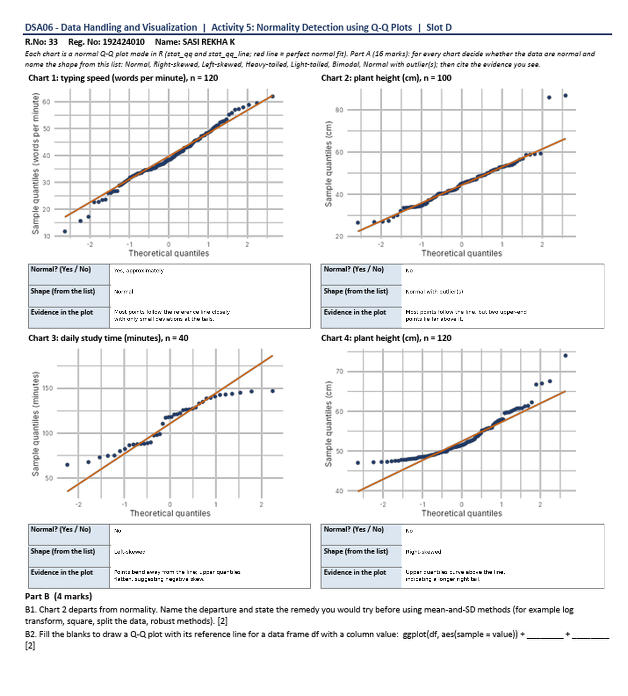

Part A – Answers in Table Format
Each Q-Q plot is compared with the reference line. Points close to the line suggest approximate normality; systematic curves or isolated points far from the line suggest non-normality.
Chart | Normal? (Yes/No) | Shape | Evidence in the Plot
Chart 1  Typing speed  (n = 120) | Yes  (approximately) | Normal | Most points lie close to the reference line. Only small differences appear near the lower and upper ends, so the data are approximately normally distributed.
Chart 2  Plant height  (n = 100) | No | Normal with outlier(s) | Most points follow the reference line, but two points at the upper end are far above it. These unusually large values indicate possible high-end outliers.
Chart 3  Daily study time  (n = 40) | No | Left-skewed | The points show a systematic bend away from the reference line, and the upper quantiles flatten. This pattern suggests a negatively skewed distribution.
Chart 4  Plant height  (n = 120) | No | Right-skewed | The points curve upward above the reference line in the upper quantiles, with several large values. This suggests a longer right tail.

Part B – Answers

B1. Choose two charts that depart from normality. Name the departure and suggest a remedy.
1. Chart 2 – Normal with outlier(s): Two points at the upper end are far above the reference line, while most of the other points follow it. First, check whether these values are data-entry or measurement errors. If the values are genuine, do not remove them without justification; consider robust statistical methods or report an analysis with and without the outliers.
2. Chart 4 – Right-skewed: The upper quantiles bend above the reference line, showing a longer right tail. If the measurements are positive, try a log transformation and then draw the Q-Q plot again. If the data remain skewed, consider robust or non-parametric methods instead of relying only on mean-and-standard-deviation methods.

B2. Fill in the blanks to draw a Q-Q plot with its reference line in R.
Completed code:
ggplot(df, aes(sample = value)) +
stat_qq() +
stat_qq_line()
Explanation: stat_qq() plots the sample quantiles against theoretical normal quantiles. stat_qq_line() adds the reference line, which helps assess whether the sample is approximately normal.

Conclusion
Chart 1 is approximately normal. Charts 2, 3, and 4 show departures from normality: possible outliers in Chart 2, left-skewness in Chart 3, and right-skewness in Chart 4.

